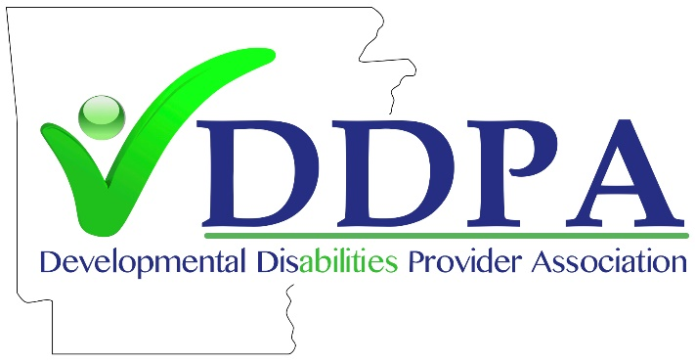

DDPA “STATE OF THE ASSOCIATION” REPORT
April 20, 2023

Since the appearance of the Covid-19 virus in March of 2020, DDPA members have been subjected to “waking up to a new world” daily. The first two questions of the day were how many beneficiaries and employees were absent due to Covid and are we able to remain open based on the infection levels. Plans were being made daily because of the pandemic. Provider agencies ramped up efforts to protect the health of their clients and employees. The wearing of masks and following stringent contact reducing rules became the order of the day. Helping those served that did not fully understand the serious nature of Covid was an ongoing struggle. It was especially difficult for residents of Intermediate Care Facilities for those with IDD (ICF/IDD) as they were physically isolated from their family and friends. It was the most difficult time of all. However, DDPA members helped each other by constantly sharing information and providing guidance to each other.
As we reach the end of the federal Public Health Emergency (PHE) DDPA has already turned its attention to the Medicaid eligibility redetermination process as members try to ensure continued Medicaid coverage for the individuals they serve. All members continue to struggle with inadequate Medicaid reimbursement rates for CES Waiver Services, EIDT services, ADDT services, and ICF/IDD services. The combination of limited rate increases in the past 10 years, along with significant inflation in the cost of food, fuel, and housing, along with an unprecedented workforce shortage has created a “perfect storm” that is jeopardizing the stability of the statewide network of community providers.
The DDPA Board of Directors has continuously worked to strengthen the foundation of the Association. One of the more significant accomplishments was the establishment of work committees to involve more employees of our member organizations. As a result of this effort there are the following work committees:
- ADDT
- EIDT
- ICF
- CES Waiver
- Transportation

There were also three (3) sub-committees established as well. These were:
- Therapy – subcommittee of EIDT
- Supported Employment – subcommittee of ADDT
- 14c programs – subcommittee of ADDT (which is now a committee unto itself)

As a result of the establishment of all these committees, there have been 105 additional employees of DDPA member organizations participate in these work committees. The ability to share information and ideas among work committee participants has been invaluable and only strengthens our association and provider network.
In addition to these ad-hoc committees, DDPA also has standing committees that are established in the associations by-laws. These committees are as follows:
- Governmental Affairs Committee (GAC)
- Training Committee
- Strategic Planning Committee
The Governmental Affairs Committee (GAC) works in cooperation and coordination with our lobby group WSG. This important committee addresses all issues that affect providers and involve governmental agencies. Sometimes the GAC will refer specific issues to the appropriate work committee for a recommendation before a final strategy is developed to address the concern. GAC is also involved with the review of all bills that affect DDPA members during legislative sessions. WSG is also charged with monitoring bills filed or planning to be filed that will have an impact on DDPA members.
The major accomplishment regarding the GAC was, with guidance and help of WSG, the establishment of the DDPA Political Action Committees (PACs). The PAC is a vehicle that allows the association to make monetary contributions to the election campaigns of candidates that support services for individuals with IDD along with DDPA members that provide these needed services. This past election cycle, the DDPA PAC contributed to the election campaigns of 55 candidates and is pleased to report that all 55 won their respective races. Dana Wills of WSG and Craig Cloud, chair of the PAC board, should be recognized for this effort.
The Training Committee is critical to DDPA’s ability to hold annual spring and fall conferences. This committee is charged with securing presentations along with company vendors that wish to display their wares. The training committee is looking at expanding training opportunities by arranging for topic specific one-day training courses. At present, there is a one-day training scheduled for July 18th, with the topic being “Compliance”.
The Strategic Planning Committee has just been re-activated and is in the process of working with the DDPA Board of Directors to create a “roadmap for the future”, which includes strategies to continue to strengthen the association as well as increase our voice when it comes to governmental decisions that affect services and supports to individuals with IDD.
Other DDPA accomplishments include the funding of a wage study by the consulting firm JVGA. This study, using actual financial data from twenty-one (21) DDPA member organizations, developed a recommended wage range for direct support professionals (DSP) that would be the basis for much needed Medicaid reimbursement rate increases for CES Waiver, EIDT, ADDT, and ICF/IDD services. Ron Ekstrand coordinated the study and should be applauded for his leadership on this important project.
DDPA was also able to delay the promulgation of new CES Waiver rules until DDPA was able to meet with DDS officials to request needed changes to the proposed rules. As a result of this, there have been significant changes in the proposed CES Waiver rules and the promulgation process will not begin until a final meeting between DDPA representatives and DDS is completed and the proposed rules are agreed upon. Sabrina Woodson, executive director of Focus, should be recognized for managing this effort.
Lastly, during the recent legislative session a bill was introduced to protect the ability of programs to utilize 14c certificates to pay commensurate wages to workers in their work centers. This was a tremendous accomplishment as several states have eliminated the use of 14c certificates. A special thank you goes out to Karen Kight, executive director of Abilities Unlimited of Hot Springs for spearheading this effort. In addition, all the DDPA members that secured a positive vote on this bill from their local legislators are to be commended as well. The bill passed and was signed into law by Governor Sanders.
DDPA recognizes the strength of the association is directly tied to the strength and support of its members. It is critical, as we move forward, that all members participate in the building of an even stronger and more effective association.

